Speeds -> velocities
Behind -> before
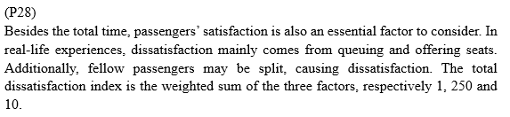
第三行第一句改成 ...and the standard variance of same-row passengers

